Assessment for Math 142 Final

1. (10 points) Solve by finding all values of θ within the interval 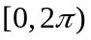
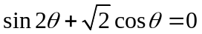

__________________________

2. (10 points each) A fisherman leaves his home port and heads in the direction N70ºW. He travels 30 mi and reaches Egg Island. The next day he sails N10ºE for 50 mi, reaching Forrest Island.

a) Find the distance between the fisherman’s home port and Forrest Island. (Round the answer to two decimal places)
__________________________

b) Find the bearing from Home to Forrest Island. (Round the answer to two decimal places)

__________________________

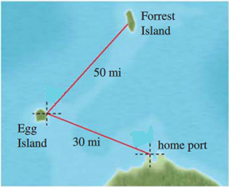

Rubric

Question1:

0 points – no work or proceeded with the problem incorrectly due to using incorrect identity

1 point – double angle identity was used correctly but steps used afterwards to isolate/solve the trig functions were incorrect.

2 points – Used identity correctly and factored the equation correctly but steps after were incorrect.

3 points – Used identity correctly, factored the equation correctly, and found the correct trig. ratios (ie-solved for the trig functions correctly)

4 points – problem was done correctly excepts for minor errors when finding the angles that satisfy the equation.

5 points – everything is completely correct

Question 2:

0 points – no work/everything incorrect

1 point – Set up angles in picture correctly or stated Law of Sines/Cosines formulas correctly but did not plug information into formulas correctly

2 points - Set up either Law of Sines OR Law of Cosines correctly using whatever angles they had drawn in their picture. (only one correct)

3 points – Wrong angles but law of sines AND cosines formulas were set up correctly using whatever angles they had drawn in their picture.

4 points – Correct angles and formulas set up correctly but a minor calculation error or direction bearing error.

5 points – Everything correct

